Original article:
Giant ossifying fibroma with pus discharging siiius
¹ Dr. Jigna S Shah (MDS)1 , ² Dr.Mahalaxmi Panda
¹ Professor and Head, ² Post Graduate Student

Department of Oral Medicine and Radiology, Government Dental College and Hospital, Ahmedabad

Corresponding, author: Dr. Mahalaxmi Panda

Abstract:
Cemento-ossifying fibroma (COF) is a rare, benign fibro-osseous lesion of the jaws exhibiting well-circumscribed, unilocular radiolucency mixed with radiopacity based on the type of mineralized tissue it contains. [1]In 1872, Menzel gave the first description of variant of ossifying fibroma. It was later described by Montogomey in 1927. In 1992, WHO named the separate lesions of cementifying fibroma & ossifying fibroma as single entity of cemento- ossifying fibroma. A 21 year old young male patient reported to Government Dental College & Hospital with complaint of pain and pus discharge from mandibular posterior region since 1 month. Patient had a large swelling in mandibular right posterior aspect causing facial asymmetry. He gave history of exfoliation of lower right 2nd molar before 1 year. No history of trauma was present. The past dental history was very significant that patient noticed a small swelling in the right side of the face eight years back which had gradually grown to attain a huge size, extra- orally as well as intra-orally. Patient had pain in the right mandibular teeth with pus discharge from molar area since 1 month which did not subside on taking medications. Except these on general examination, he was moderately built and nourished and vital signs were within normal limits.

Journal of Government Dental College and Hospital

Now Indexed in

Cite Factor

INTRODUCTION
Cemento-ossifying fibroma (COF) is a rare, benign fibro-osseous lesion of the jaws exhibiting well-circumscribed, unilocular radiolucency mixed with radiopacity based on the type of mineralized tissue it contains. [1]In 1872, Menzel gave the first description of variant of ossifying fibroma. It was later described by Montogomey in 1927. In 1992, WHO named the separate lesions of cementifying fibroma & ossifying fibroma as single entity of cemento- ossifying fibroma.However, in 2005, the term was reduced to ossifying fibroma.[2] It is defined as well-demarcated lesion composed of fibrocellular tissue and mineralized material of varying appearances. (WHO) [2,3] The origin of COF has been associated with the periodontal membrane that has multipotent cells capable of forming cementum, lamellar bone, and fibrous tissue. [1,4]

Journal of Government Dental College and Hospital,
Ahmedabad
Gujrat

…. Value based research

These benign fibro-osseous lesions can arise from any part of the facial skeleton and skull with over 70 percent of cases arising in the head and the neck region and principally in the jaws. [5] Larger lesions with size over 80mm in greatest diameter have been termed as “giant ossifying fibroma”. [1,2,5]
It can occur at any age, common in young adults (2nd and 3rd decades) with female predominance, generally asymptomatic until the growth produces a noticeable swelling and mild deformity, displacement of tooth may be an early clinical feature. It is a relatively slow growing tumor and may be present for some years before clinical presentation. The majority of lesions are found in the posterior region of the mandible and are usually situated at the roots of the teeth or in the periapical region.[1,5,6].
Radiographically, the lesion usually has a distinct boundary and in the early stages, it presents as a lucent area. As the lesion matures, bone densities appear, transforming the lesion into a radiopaque mass surrounded by a "halo" of less ossified tissue. The growth of the lesion may result in displacement of teeth or the inferior alveolar canal. A significant point is that the outer cortical plate, although displaced and thinned, remains intact. The lamina dura of involved teeth usually is missing, and resorption of teeth may occur.[3,9,11]Differential diagnosis should be performed, preferably with other fibro-osseous lesions of the maxilla such as fibrous dysplasia or osseo-cementifying dysplasia [5,9]A definitive diagnosis is usually established based on the
correlation between clinical, radiological, and histological findings.[1]The lesion is sharply circumscribed and demarcated from bone and it should be excised conservatively. Recurrence is rare.[6] In this paper, a rare case of a giant cemento-ossifying fibroma occurring in a mandible of a young patient is presented with superadded infection.

CASE REPORT
A 21 year old young male patient reported to Government Dental College & Hospital with complaint of pain and pus discharge from mandibular posterior region since 1 month. Patient had a large swelling in mandibular right posterior aspect causing facial asymmetry. He gave history of exfoliation of lower right 2nd molar before 1 year. No history of trauma was present. The past dental history was very significant that patient noticed a small swelling in the right side of the face eight years back which had gradually grown to attain a huge size, extra- orally as well as intra-orally. Patient had pain in the right mandibular teeth with pus discharge from molar area since 1 month which did not subside on taking medications. Except these on general examination, he was moderately built and nourished and vital signs were within normal limits.
On clinical examination a diffuse ovoid swelling was seen in the right side of the face 7x8 cm in size extending antero-posteriorly from right ala of nose to pre-auricular region & superoinferiorly from infraorbital margin to 2 cm below the lower border of mandible. On palpation, swelling was bony hard in consistency, non-tender, fixed to underlying structures with normal overlying skin. [Figure 1] Regional lymph nodes were palpable & non tender.
Intraoral examination revealed a localized, solitary swelling extending from mandibular right lateral incisor to pterygomandibular raphe region,bony hard in consistency, non- tender with significant expansion of buccal & lingual plates and obliteration of buccal vestibule. Overlying mucosa appears normal except presence of a pus discharging sinus in the periapical region of mandibular first molar with displacement of premolar and molars and heavy deposits of calculus. All teeth in the affected quadrant of mandible were non-vital with grade III mobility in 1st molar. Mandibular right 2nd and3rd molars were absent with anterior displacement of 43-46, leading to crowding & mal-alignment in anterior region of mandible.[Figure 2]
Considering the history, extraoral and intraoral examination, benign bony lesion was suspected with secondary infection. Clinically, localized fibro-osseous lesion was considered in differential diagnosis. Various investigations were performed to rule out the possibility of either benign tumor or fibro-osseous lesion.
Periapical radiograph of mandibular premolar-molar region, Panoramic radiograph and Postero-anterior view of the skull showed well circumscribed, radio-opaque lesion with patchy radiolucencies interspersed within, giving cotton-wool appearance with radiolucent capsule that extended from canine region to posterior border of ramus and from coronoid process to lower border of mandible, obscuring the right mandible causing displacement of the inferior alveolar canal and bowing of mandibular floor. Resorption of roots of 1st molar was present with anterior displacement of all teeth. The right mandibular occlusal radiograph showed expansion of both buccal and lingual cortical plates. Radiographic features were suggestive of fibro-osseous lesion.[Figure 3]
Computed tomography of the maxillofacial region revealed a well-defined, heterodense, space occupying, and expansile lesion in the right mandible of size 7x8 cm with bicortical expansion and thinning, sclerotic margin and scattered amorphous calcification with downward bowing of lower border of mandible. CT features also confirmed our diagnosis of fibro-osseous lesion. [Figure 4] The radiologic differential diagnosis considered was a large complex odontoma, ameloblastic fibro-odontoma and osteosarcoma.
Under local anaesthesia, an incisional biopsy was taken which showed parakeratinized hyperplastic stratified squamous epithelium overlying a fibrocellular connective tissue. Some areas showed dense collagen fiber bundles with spindle shaped fibrocytes whereas some show pleomorphic cells with enlarged and hyperchromatic nuclei. Some areas of osteoid formation with well defined osteoblastic rimming are seen. No evidence of permeative bone growth is present. This is suggestive of cemento-ossifying fibroma. [Figure 5] Routine blood investigations were within normal range. Surgical resection of the tumor was carried out under general anaesthesia without any complications. [ Figure 6] After one-year of resection of the lesion, the patient did not complain of any type of symptoms. [Figure 7]

DISCUSSION
Ossifying fibroma is one of the most common benign fibroosseous lesions characterized by replacement of normal bony architecture with benign connective tissue matrix having varyingamounts of mineralized material that can be bone and/or cementum hence term ‘cemento- ossifying’.[12] It exclusively involves the maxillofacial bones.
It is a disorder of unknown etiology.Most reports suggest earlier trauma in the area of the lesion. Trauma acts as a predisposing factor which shows that it is not a true neoplasm but possibly, a connective tissue reaction. Various authors have agreed that infection and dental extraction stimulate the periodontal membrane to produce and deposit cementum. After trauma, such as tooth extraction, the remaining periodontal tissue that is attached to the wall of the alveolus may serve as the origin of COF. [1,13] The case reported here did not reveal any history of trauma.Our patient presented with sinus and active discharge since a month. This may be due to periodontal infection arising from heavy deposits of calculus present on occlusal as well as interdental surface of all teeth in affected quadrant. This also points towards unilateral chewing habit of patient due to discomfort from chronic swelling.All this led to bacterial invasion and subsequent infection and pus discharging sinus which is usually a rare feature to be associated with OF.
Clinically it presents as slow growing tumor of jaw most often seen in 3rd-4th decades of life. They occur more frequently in women than in men and predilection for the site is mostly mandibular premolar –molar region. [1]Our case was found in a male patient enveloping entire half of mandible which is in accordance to previous reports.
Most lesions are asymptomatic and typically show expansile growth centrally within jaws, characteristically behave in benign form but occasionally may present as an aggressive gigantiform lesion[4,6,8]. In our case, patient presented with asymptomatic swelling in posterior region of mandible that persisted for long duration of around 8 years to produce noticeable asymmetry of face suggestive of a benign lesion.
Degree of mineralization determines the radiographic presentation.- early, mixed & mature stage. In the initial/early stage, the COF appears as a well-defined radiolucent lesion with no evidence of internal radiopacities. As the tumor matures, there is evidence of calcification so that the radiolucent area becomes flecked with opacities until ultimately the lesion appears as an extremely radiopaque mass in the mature stage. [8] The margin of lesion is well defined with presence of sclerotic rim in host bone as a result of peripheral osteocondensation. The borders
are well defined, and a thin radiolucent line representing a fibrous capsule separates the lesion from the surrounding bone. [1,4,7,8,9]. The present case showed similar findings at mature stage having large radiopaque lesion with sclerotic rim but with nonhomogenous appearance due to coalescing multipleradiopaque foci surrounded by radiolucent line. Root divergence and resorption are not uncommon. The lamina dura of involved teeth usually is missing. These features were seen in our patient [13] Also the periphery showed slightly ragged/ irregular margin suggesting that tumor is in active proliferating stage & is continuously enlarging. But this feature resembles that of osteosarcoma usually. But since the lesion persisted for about 8 years, sarcomatous lesion was not considered.
The important diagnostic feature of COF is centrifugal growth pattern, expanding equally in all directions producing round tumor mass. The CT picture in our case showed similar features with thinning & intact margins concluding benign nature of lesion.[1,7-9]
Histopathology features of COF reveals many interlacing collagen fibers, seldom arranged in discrete bundles, interspersed with large numbers of active proliferating fibroblast & cementoblasts. As the lesion matures islands of cementum enlarge and ultimately coalese.(3,5) The connective tissue is characterized by many small foci of irregular bony trabaculae which resemble the Chinese letter shape of trabaculae in fibrous dysplasia and thus can lead to a possible diagnostic error.[4,10] COF has woven bone rimmed by osteoblast that lay down lamellar bone.This features were present in this case as well.
As the lesion is well circumscribed they can be easily removed from the surrounding tissue. Since the lesion present in our case was large and hence entire right hemimandibulaectomy was done. Radiotherapy is contraindicated due to radio-resistance & post radiation complication. [1,10]
Differential diagnosis involves fibrous dysplasia, odontome, osteosarcoma. [1,12] Fibrous dysplasia has blending margin with surrounding bone & linear expansion of cortex, which cannot be in exact parallel relationship thereby failing to produce round tumor mass seen in COF. Microscopically it has woven bone, not lamellar bone. [1] Recently, a study demonstrated that the presence of peritrabecular clefting in fibrous dysplasia is an important histopathological feature for distinguishing fibrous dysplasia from OF [14] Ossifying fibroma lack true fibrous capsules but has minimal bone infiltration that distinguishes it from FD.[12]
Odontomes shows tooth like structures or denticles that look like deformed teeth. Complex odontomes are differentiated from OF by their tendency to be associated with unerupted molar teeth. Also they appear in much younger patients than OF. Also the degree of radiopacity is more than adjacent teeth. COF shows radioopaque foci. In large OFs, osteosarcoma may be also considered in the clinico-radiographic diagnosis due to periosteal spiculation due to active growth. [1,8,12- 14]

CONCLUSION
Fibro- osseous lesions are rare as such and it is very rare to find secondary infection to develop with this type of lesion.It may look like either odontome or sarcomatous lesion. Hence differential diagnosis is very important before planning the treatment. A correlation between clinical, imaginological and histopathological features is the key to establish the correct diagnosis.

REFRENCES:

- R Mithra, PavitraBaskaran, and M Sathyakumar. Imaging in the Diagnosis of Cemento- Ossifying Fibroma: A Case Series. Journal of Clinical Imaging Science
- World Health Organization Classification of Tumours. Pathology and Genetics of Head and Neck TumoursInternational Agency for Research on Cancer (IARC)2005
- Ah Hup M. Ong, BDS(S’pore), MSc(Lond)* Chong HuatSiar, BDS(Mal), MSc(Lond), FDS(Glas), MRCPath† Cemento-ossifying fibroma with mandibular fracture. Case report in a young patient. Australian Dental Journal 1998;43:(4):229-33
- Demetrio Tamiolakis1,Vasilios Thomaidis2,Ioanis Tsamis2 Cementoossifying Fibroma of the Maxilla: a Case Report. ActaStomat Croat 2005; 319-321
- Rangila Ram, Anita Singhal, ParulSinghal. Cemento-Ossifying Fibroma. Contemporary clinical Dentistry. Jan-Mar 2012/ Vol 3/ Issue 1
- Srinivasa Prasad B, KoteswaraRao2, 3Devaki Swathi. CEMENTO-OSSIFYING FIBROMA-A CASE REPORT . Annals & Essence of DentistryVol. - II Issue 4 Oct – Dec. 2010
- M Araki, K Matsumoto, [...], and K Komiyama. Unusual radiographic appearance of ossifying fibroma in the left mandibular angle..Dentomaxillofacial Radiology. British institute of radiology
- Chandramani More, KrushnaThakkar, MukrshAsarani. Indian Journal of Dental Research. Year 2011/ Vol 22/ Issue 2
- Y Liu, H Wang, [...], and T Koseki. Ossifying fibromas of the jaw bone: 20 cases. Dentomaxillofacial Radiology. British institute of radiology
- V. Nagalaxmi, MithareSangmesh, Faisal TaiyebaliZardi. Cemento-ossifying fibroma of the mandible – a case report. ISSN:0975- 8437
- M. Imanimoghaddam DDS1,S.H. HosseiniZarch DDS2,S. Nemati DDS3,A. JavadianLangaroody DDS3 Cemento-Ossifying Fibroma: Study of Radiographic Features of Six Cases Iran J Radiol 2009, 6(4)
- SujataMohanty, Sunita Gupta, Priya Kumar, K. Sriram, UjjwalGulati. Retrospective Analysis of Ossifying Fibroma of Jaw Bones Overa Period of 10 Years with Literature Review J. Maxillofac. Oral Surg. (Oct–Dec 2014)
(A)
- D. Saikrishna, SujithShetty, and S. Ramya. Massive ossifying fibroma of mandible Ann Maxillofac Surg. 2014 JanJun; 4(1): 81–84.
- Márcia de Andrade, YaraTeresinhaCorrêa Silva-Sousa, Maria FernandaTeiga Marques, Maria Luiza dos AnjosPontual, Flávia Maria de MoraesRamos-Perez, Danyel Elias da Cruz PerezOssifying Fibroma of the Jaws: A Clinicopathological Case Series Study Brazilian Dental Journal (2013) 24(6): 662-666

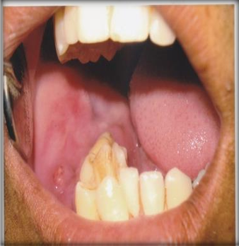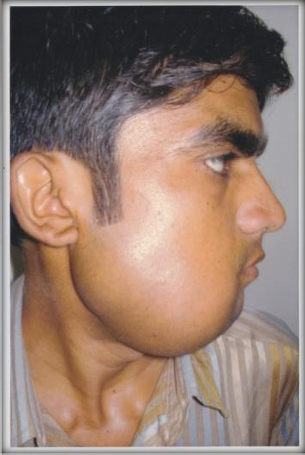
Figure 2 showing intraoral view of the lesion with
pus discharging sinus at 1st molar region
Figure 1 showing a 7x8cm swelling in right mandible right lateral view
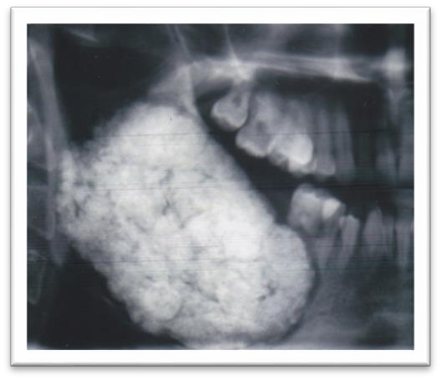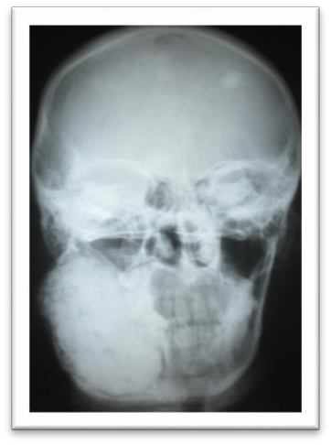

  - (B)
Figure 3 shows well circumscribed non-homogenous radio-opaque lesion with
radiolucent capsule in (A) OPG (B) PA Skull
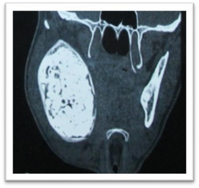
Figure 4 shows computed tomography showing well defined radiopacity with interspersed radiolucency and sclerotic border with radiolucent rim

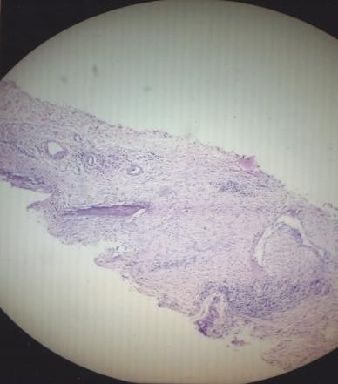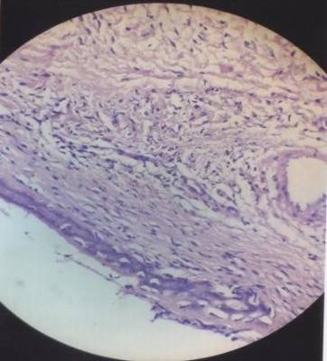

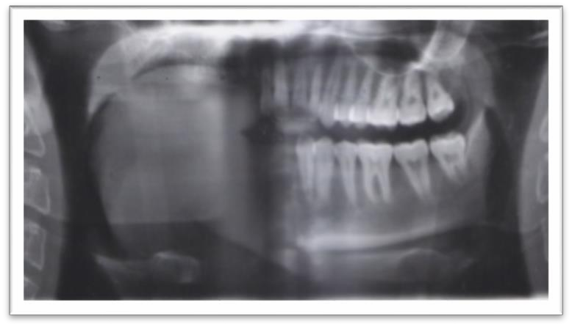
Figure 5 shows histopathological picture of Ossifying Fibroma
Figure 6 shows postoperative OPG with right hemimandibulectomy

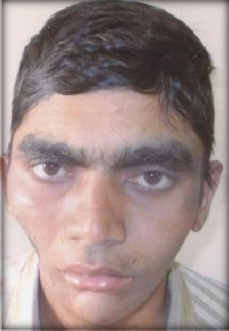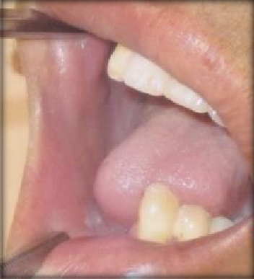

    - (B)
Figure 7 shows postoperative (A) profile (B) intraoral picture

